

Zine

A small magazine print

Open InDesign and go to File > New > Document.

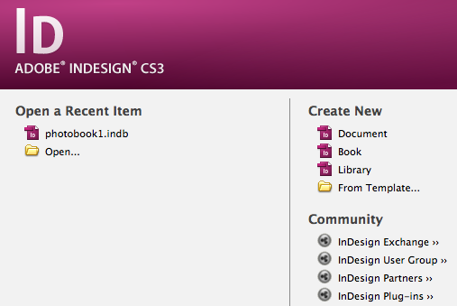

Set up the document for Print, with an A5 page size (148 x 210 mm). Set the number of pages to 10 and make sure Facing Pages is checked.
Add a Top and Bottom Margin of 19 mm, set the Inside Margin to 21 mm and the Bottom Margin to 25 mm.
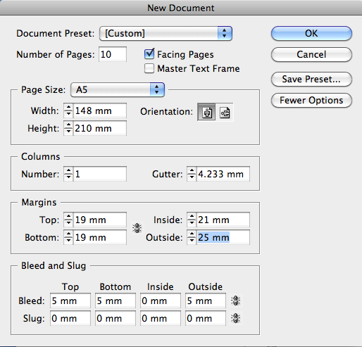
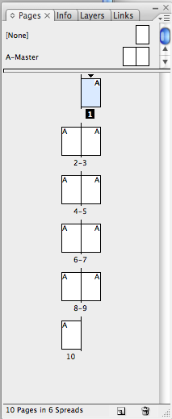
Finally, add a 5 mm Bleed to all edges except the Inside edge, and click Create. Click show pages tab

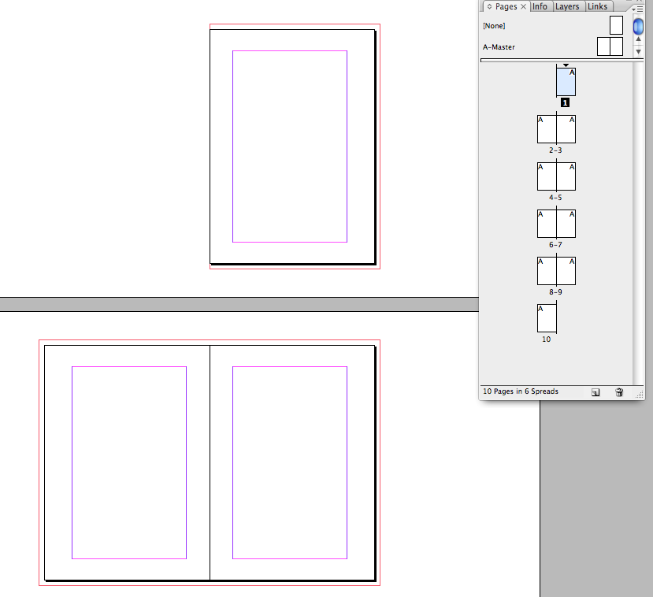

Expand the Layers panel (Window > Layers).
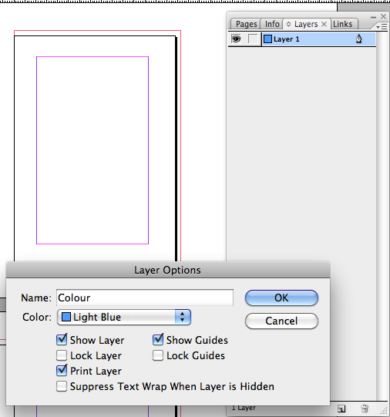
Double-click on Layer 1 and rename this Color.
Create two more new layers—Photos, and Type.
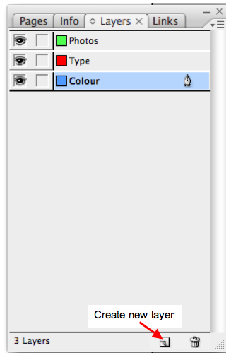

Expand the Swatches panel (Window > Color > Swatches).
Choose New Color Swatch from the panel’s drop-down menu (at top-right).
With the Type set to Process and Mode to CMYK, set the levels below to C=94 M=80 Y=5 K=0. Click Add 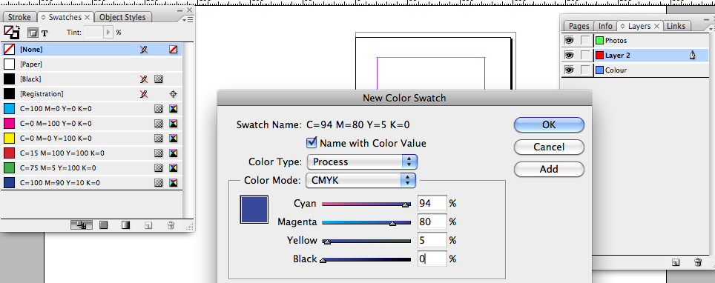and Done.
Create a second new swatch, C=0 M=88 Y=92 K=0.
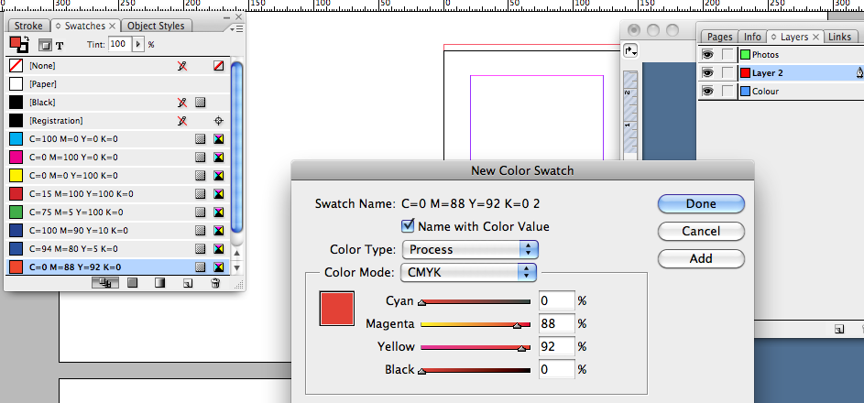

Choose New Gradient Swatch from the Swatches panel’s menu.
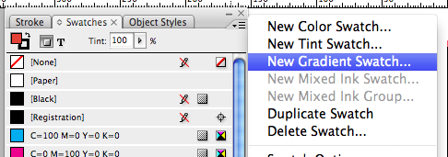

Name the swatch Zine Gradient Swatch.
Click on the left-hand stop on the Gradient Ramp,
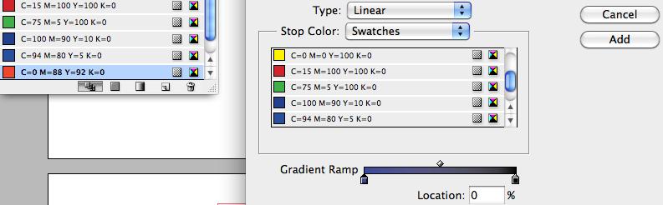and choose your blue swatch, C=96 M=82 Y=3 K=0, from the Stop Color menu.

For the right-hand stop
choose your red swatch,
C=0 M=88 Y=92 K=0.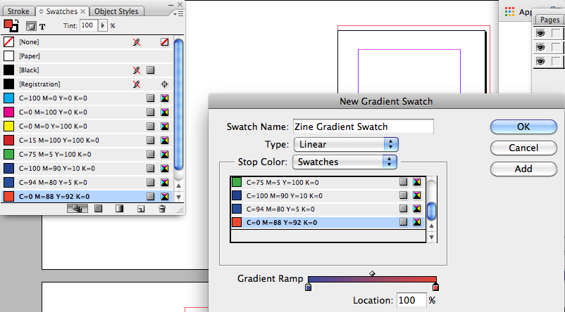
Click Add and Done.
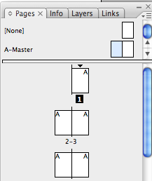
Double-click on the A-Master icon at the top of the Pages panel (Window > Pages) to bring up the master on your screen.
Use the Type Tool (T) to create a text frame across the bottom of the left-hand page.
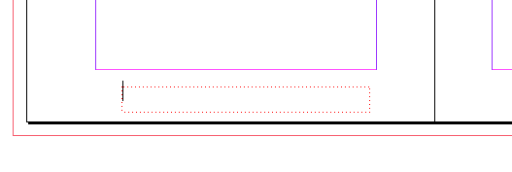

Here you can place page numbers. With your type cursor in the frame, go to Type > Insert Special Character > Markers > Current Page Number.
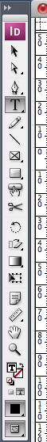
Highlight the text using the type tool,
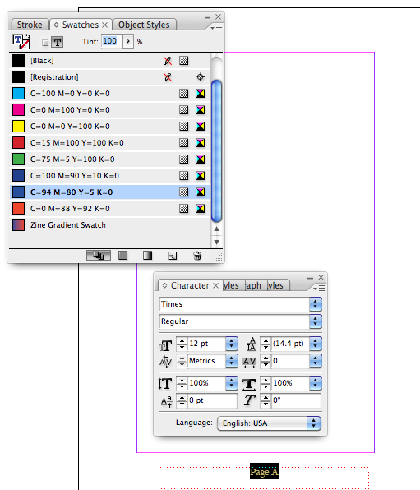
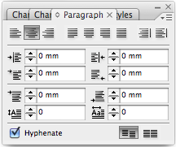

You can format the page number using the Swatches panel and Character and Paragraph panels (Window > Type & Tables > Character / Paragraph).
Centre the page number and add Page to the front

Edit > Copy and Edit > Paste the page number text frame, moving this over to the right-hand page.
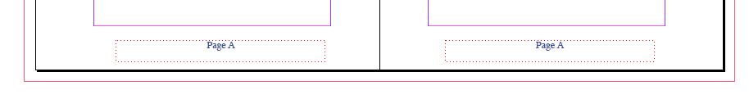
Use the Rectangle Tool (M) to create a tall, narrow shape across the left edge of the spread, taking it up to the bleed, and allowing a small area to extend onto the page.
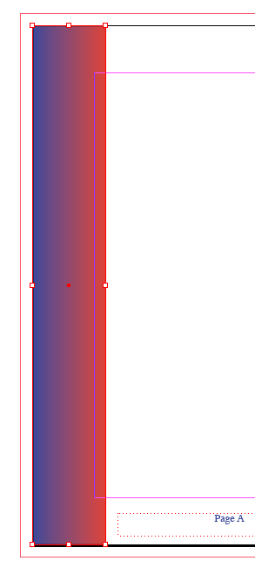
Set the Fill Color of this to Gradient Swatch.

Copy and Paste the rectangle, and on the copy, Right-Click > Transform > Flip Horizontal.
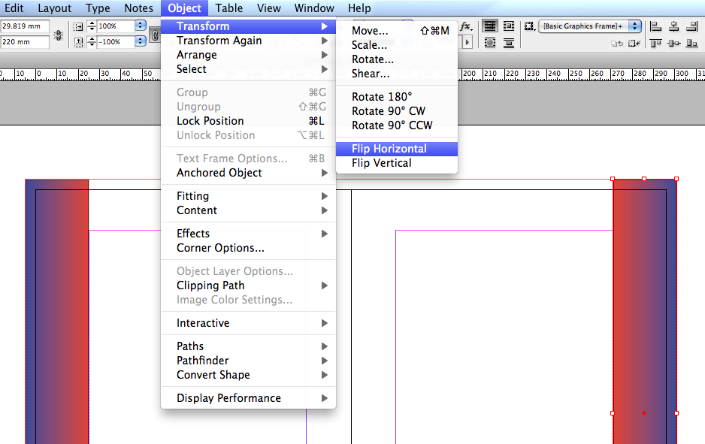
Move this over into a mirrored position on the right-hand page.
In the Pages panel Right-Click on the A-Master icon, and choose Duplicate Master Spread “A-Master”.

On the new B-Master, select and delete the page number text frames if they appear on these pages.
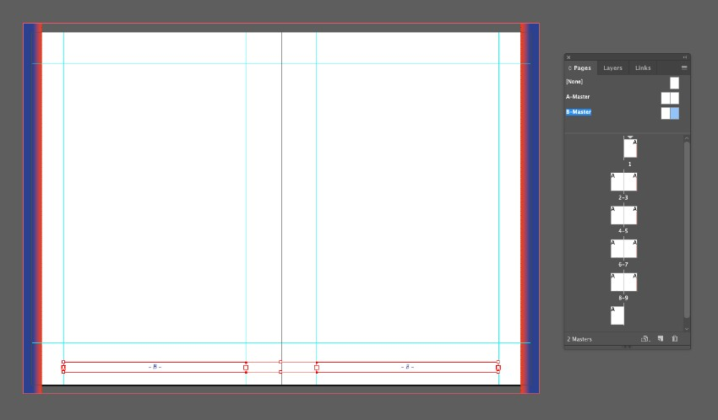
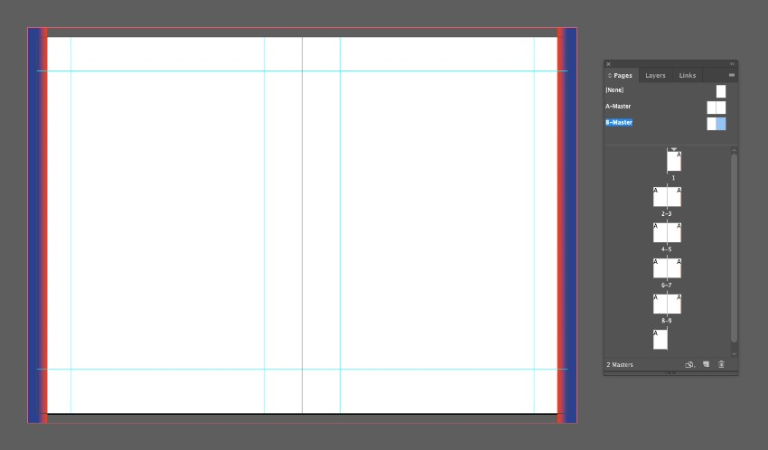

Step 5

In the Pages panel, select the top [None] master page, and choose Apply Master to Pages from the panel’s drop-down menu.
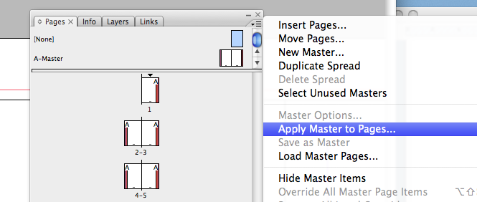
We want to have no master applied to the front and back cover of our zine, which is on pages 1 and 10 of our document. So type in 1, 10 and click OK.
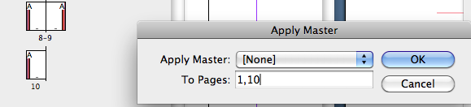
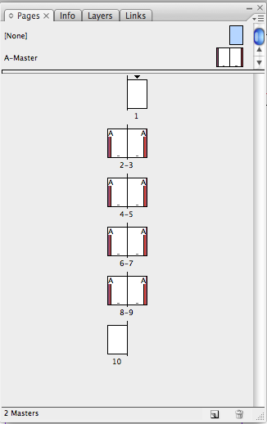

Select the B-Master icon in the Pages panel, and, as before, choose Apply Master to Pages. You want to apply the B-Master to any pages which you don’t want to have page numbers. In this case, I type in 2, 6, before clicking OK.

3. How to Section Your Zine

Step 1

In this zine, I want to split the document into two sections, with page 1 beginning on what is currently page 3 of the document.
To begin a new section, Right-Click on the page you want to start as page 1 (in this case page 3), and choose Numbering & Section Options.
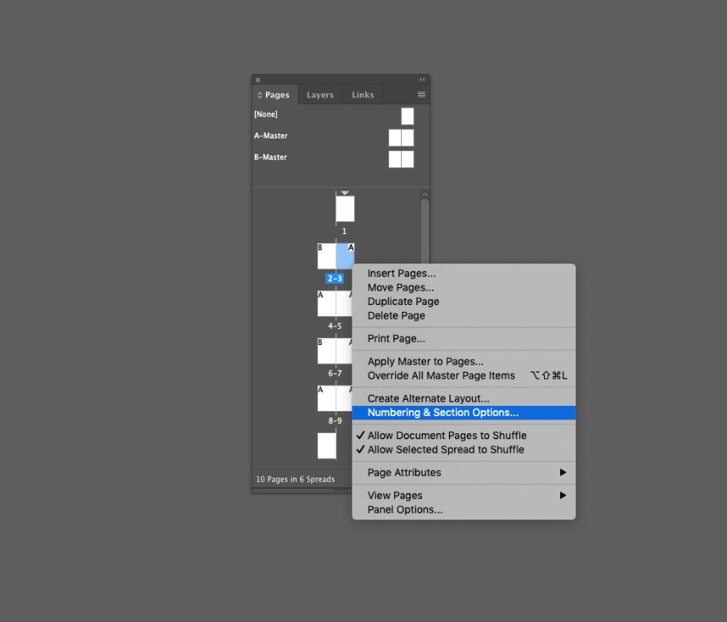

In the New Section window that opens, check Start Page Numbering at, and set this to 1.
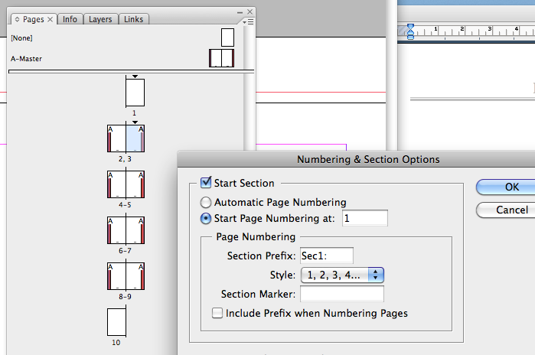
Then click OK. You might get a warning message, but don’t worry about that. Just click OK.

On the first page of the document, Right-Click > Numbering & Section Options.
As before make sure Start Page Numbering at is selected and set to 1. But this time choose a different Style for the Page Numbering, such as lowercase roman numerals. Then click OK.
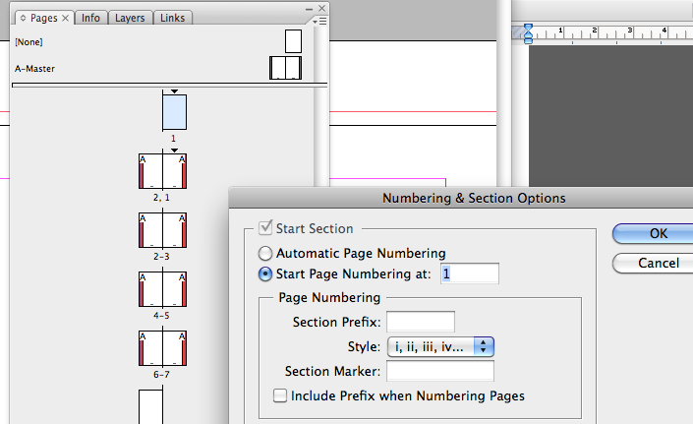
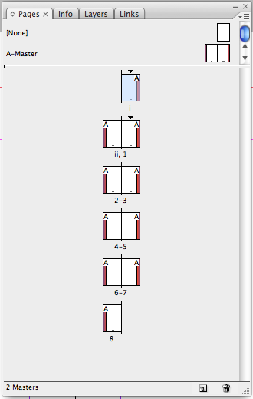

4. How to Create a Front Cover for Your Zine
Working on the first page (i) of your document, and on the Color layer, use the Rectangle Tool (M) to create a shape across the whole page, extending the edge up to the bleed on the top, right and bottom sides.
Set the Fill Color to Gradient Swatch.
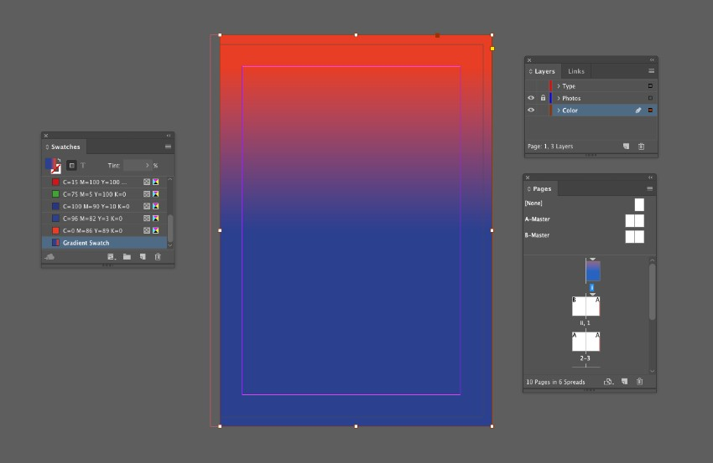
You can adjust the strength of the gradient from theGradient panel (Window > Color > Gradient). Here I want to make the gradient blend more abruptly in the center of the page.
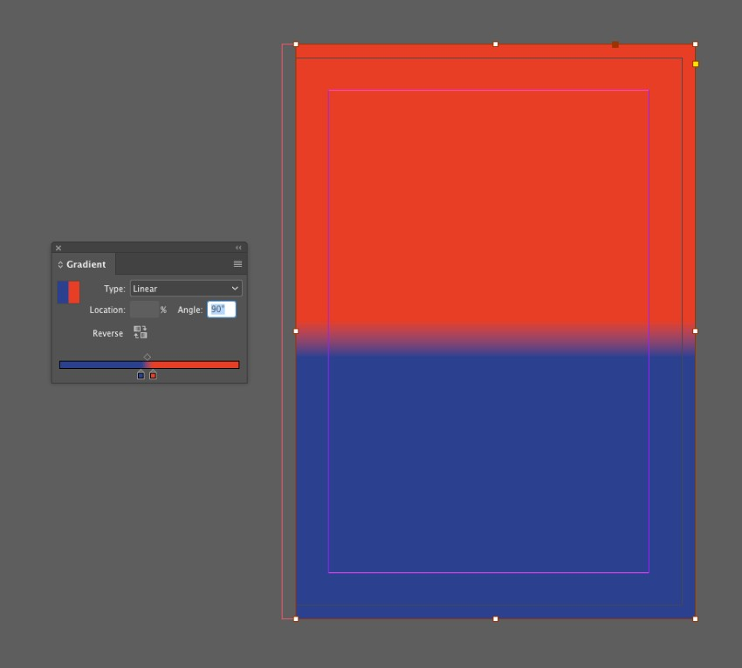

Step 2

Copy and Edit > Paste in Place the rectangle shape, adjusting the Fill to your blue swatch, C=96 M=82 Y=3 K=0.
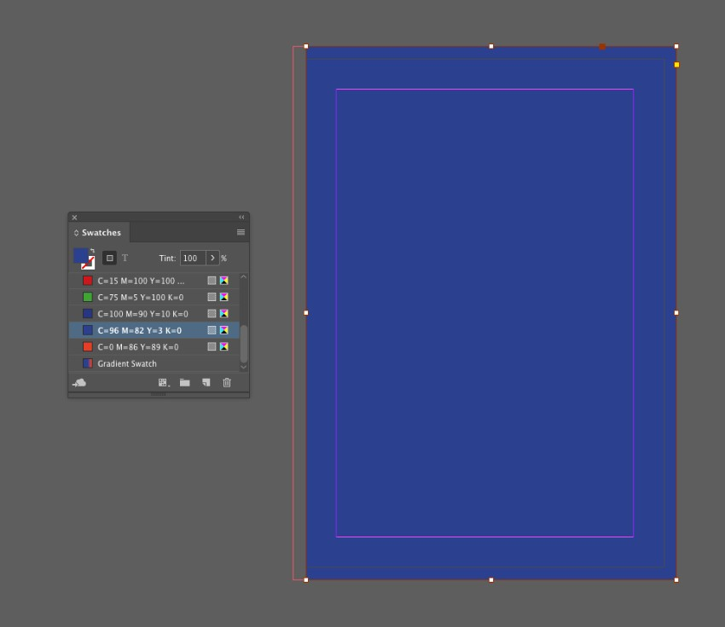
With the blue shape selected go to Object > Effects > Transparency, and bring the Opacity down to 30%.
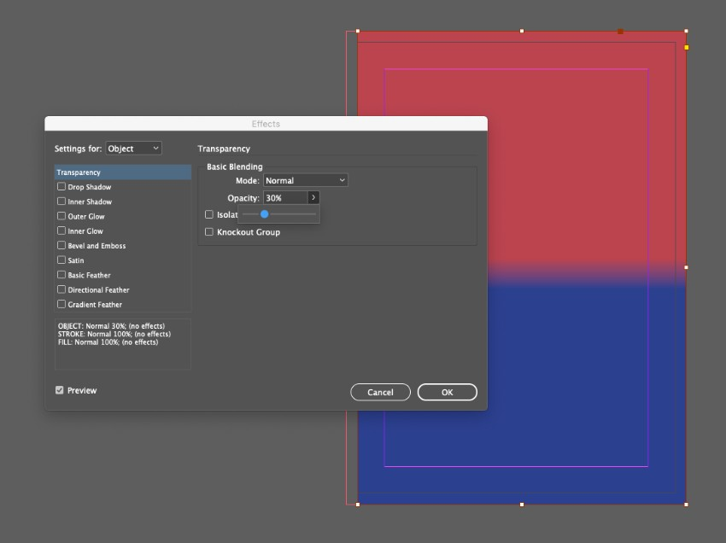
Click on Inner Glow in the panel’s left-hand menu.With the Mode set to Normal, click on the colored square to adjust the Effect Color to your red swatch,C=0 M=86 Y=89 K=0.
Increase the Opacity to 100%.
Set the Source to Centre, Size to around 55 mm,Choke to 50% and Noise to about 45%. Then click OK.
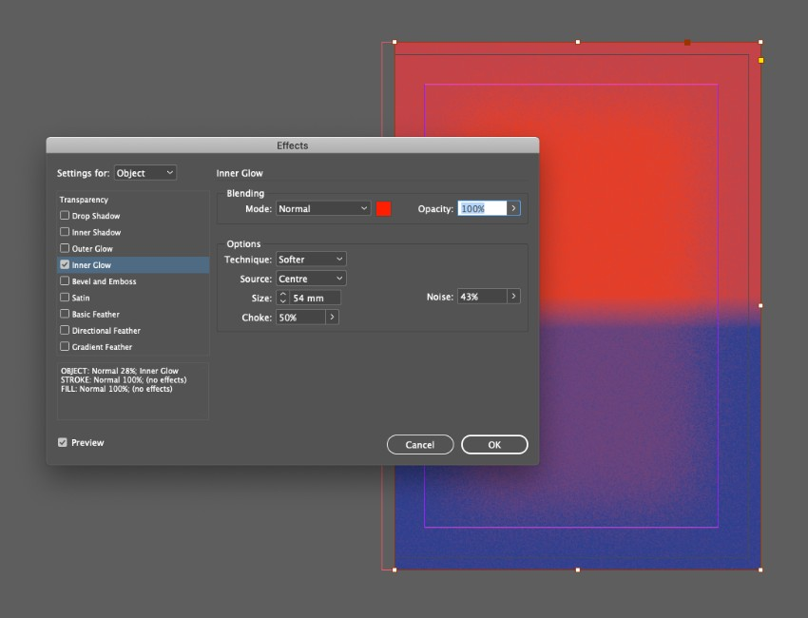

Step 3

Working on the Type layer, use the Type Tool (T) to add text to your cover, setting the Font to Cormorantand Font Color to [Paper].
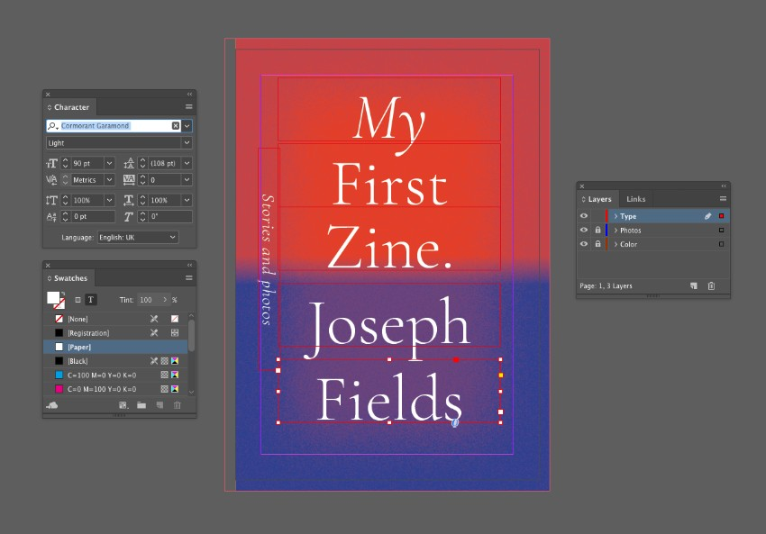

5. How to Build Up Content on the Inside Pages of Your Zine

Step 1

Select both rectangle shapes sat on the Color layer on the front cover, and Copy them.
Scroll down to the first inside spread of your zine, andPaste the shapes, moving them over onto the left-hand page.
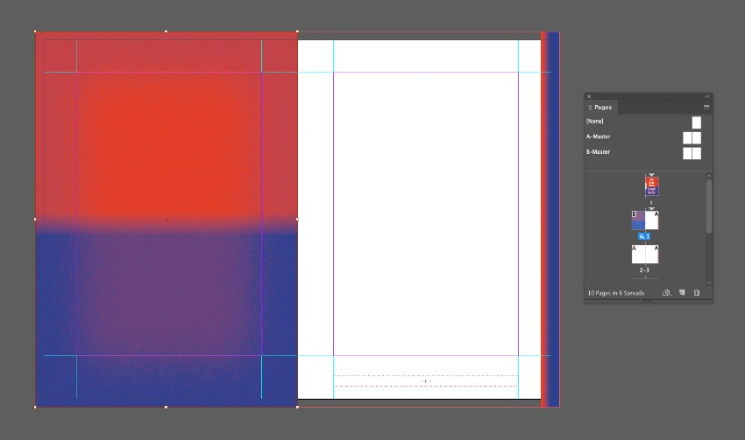

Step 2

Edit > Paste a second time, and with this copy selected, go to Object > Convert Shape > Ellipse.
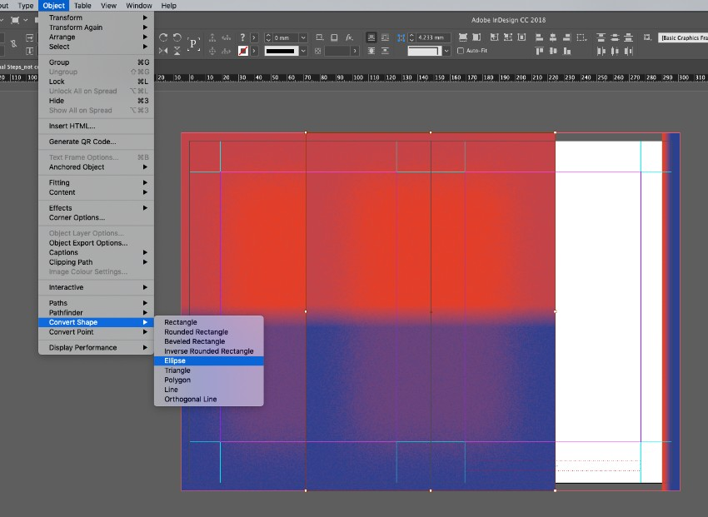
From the top Controls panel adjust the Width andHeight of the circles to 108 mm.
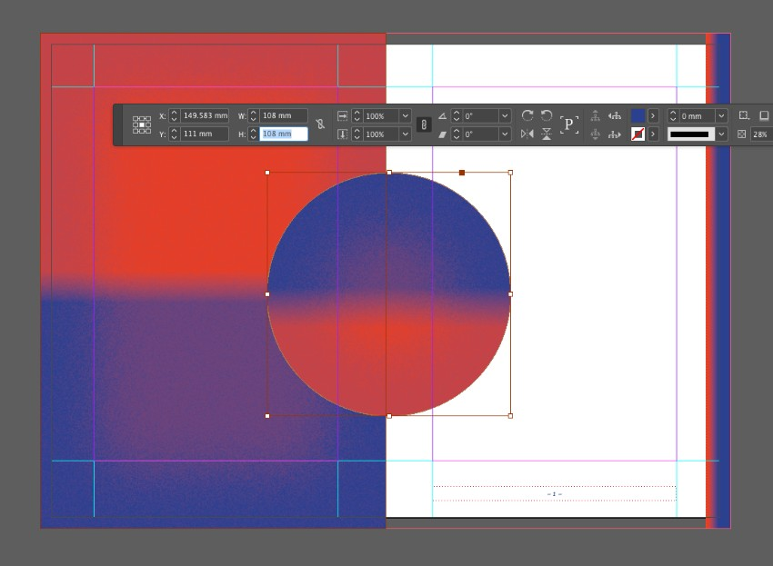
Then move these over the top of the left page, positioning them centrally. Shift the top circle slightly up and to the right to create a slightly blurry effect.
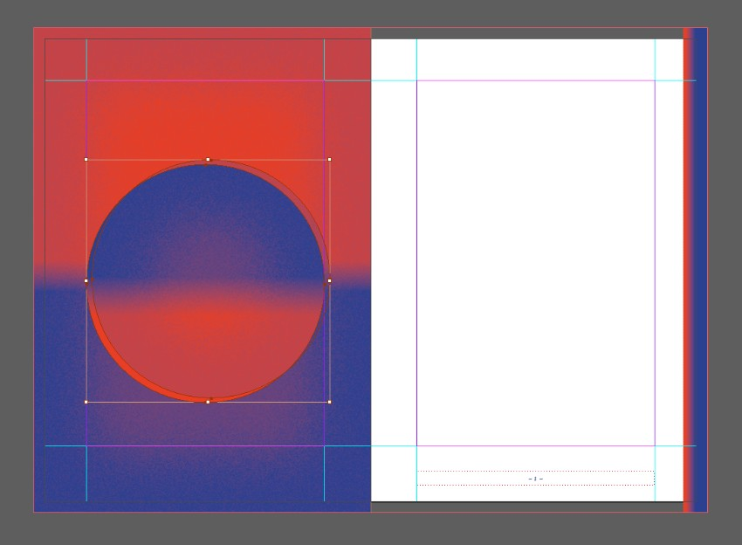

Step 3

You can add text to your zine using the Type Tool (T), and working on the Type layer.
Here, I’ve added text set in Cormorant and a blue,C=96 M=82 Y=3 K=0, Font Color, to the right-hand page of the spread.
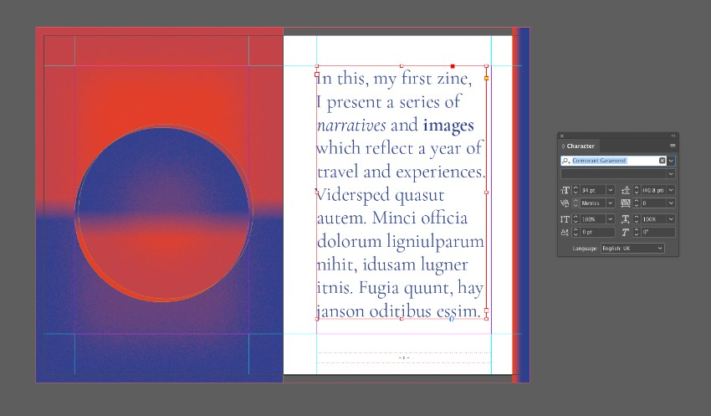

Step 4

Use the Rectangle Frame Tool (F) to create image frames on some of the pages of your zine.
Go to File > Place to drop images into the frames.
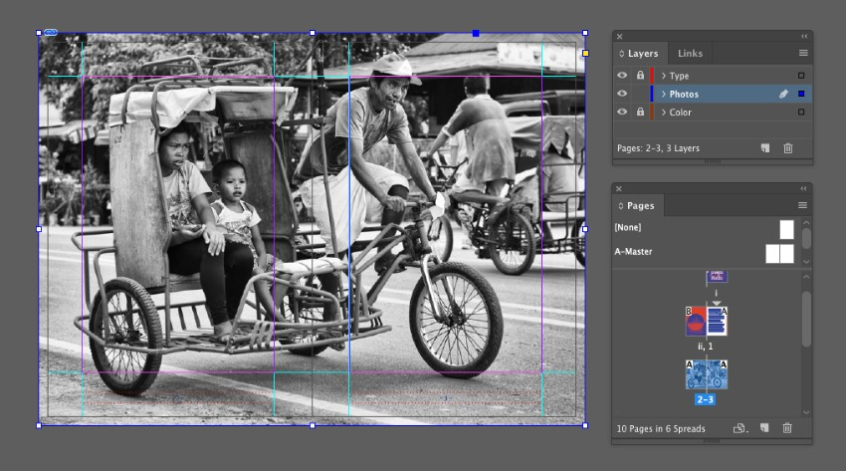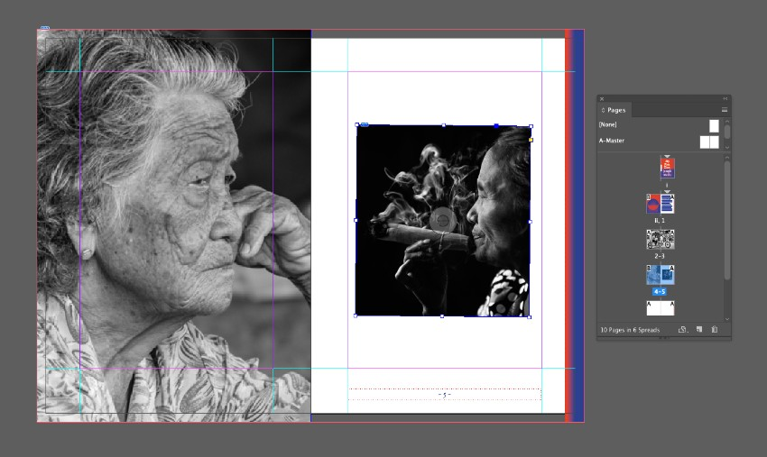

Step 5

Use the swatches you’ve already created to format text, adding a touch of color to your typography.
Here, I’ve also set the text to Align towards spine(which you can find in the top Controls panel with the Type Tool selected).
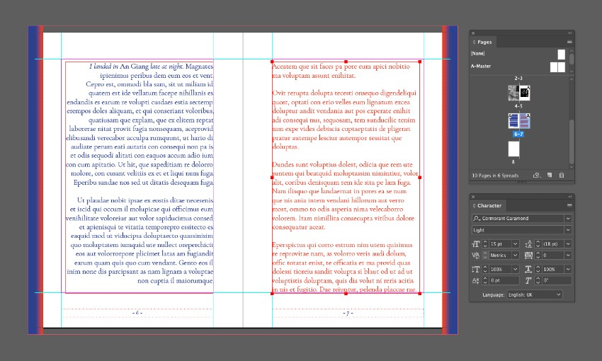

Step 6

Use elements you’ve already created, such as the colored rectangles and circles on the first spread, to create a quick and simple design for your back cover, on the final page of the document.
Make sure to add your website to the back cover too.
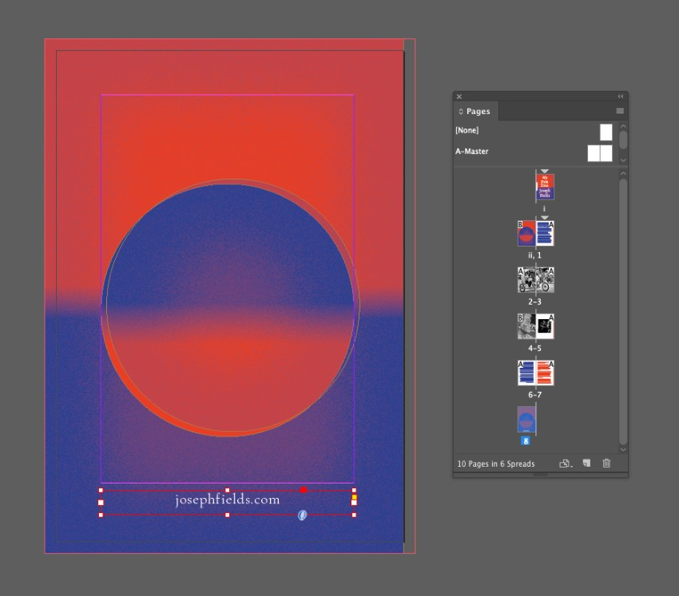

6. How to Export Your Zine for Print

Step 1

File > Save your artwork, then go to File > Export.
Choose Adobe PDF (Print) from the Format menu, name your file, and then click Save.
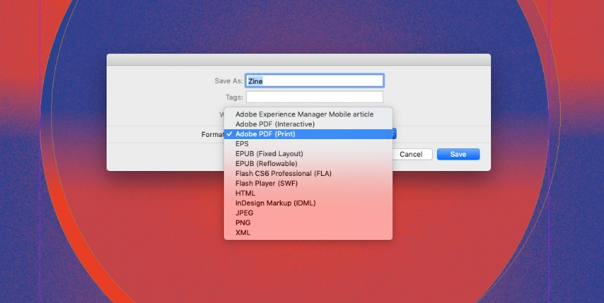


Need help just ask

